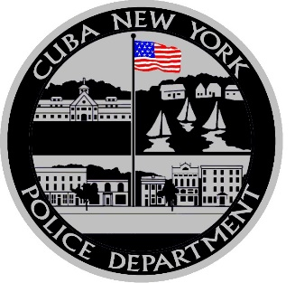

Narcotics Unit

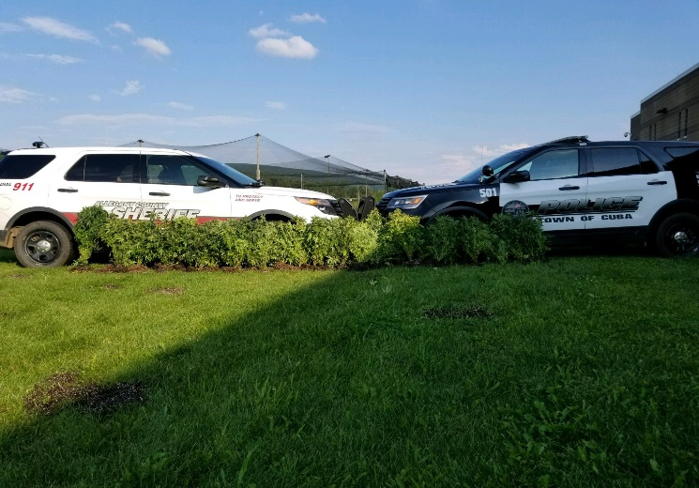
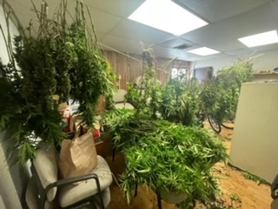
The Cuba Police Department Narcotics Unit was established in 2023 to investigate narcotics crimes at the local and federal levels occurring in our jurisdiction. This unit attempts to identify and make positive prosecutable cases against narcotics traffickers. The goal of this narcotics unit is to identify and arrest the highest-level narcotics traffickers and to realize the maximum allowable incarceration times for the defendants and the maximum amount of seizure of illegally obtained assets from those defendants. The Cuba Police Department Narcotics Unit works closely with the DEA, the Olean Police Department Street Crimes Unit, the Southern Teir Regional Drug Task Force and the Allegany County District Attorney’s Office. The Cuba Police Department Narcotics Unit is comprised of one investigator and one sergeant and works closely with all patrol staff. Anyone with any narcotics information is urged to email us at tips@cubapd.org.

